8.2 data integrity

Name __________________ class__________________

1. Calculate the checksum for blocks of data with the following byte sums using the algorithm

Divide the X by 256

Round the answer down to the nearest whole number Y

Z=Y*256

Calculate the difference (X-Z)

This value is the checksum

1450

_____________________________________________________________________________

_____________________________________________________________________________

_____________________________________________________________________________

_____________________________________________________________________________

_____________________________________________________________________________

_____________________________________________________________________________

_____________________________________________________________________________

1. Find the parity bits for each of the following bytes

A 1101101 even parity used parity bits:______

B 0001111 even parity used parity bits:______

C 0111000 even parity used parity bits:______

D 1110100 odd parity used parity bits:______

E 1011011 odd parity used parity bits:______

1. Which of the following bytes have an error following data transmission? error or not?

A 11101101 even parity used  _____________

B 01001111 even parity used _____________

C 00111000 even parity used _____________

D 11110100 odd parity used _____________

E 11011011 odd parity used _____________

4.

Parity bits can be used to verify data.

(a) The following binary number is transmitted using odd parity.

Add the missing parity bit.

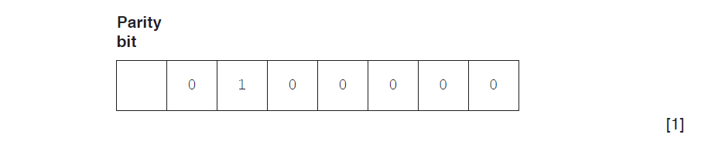

In the following data transmitted, the first column contains the parity bits, and the last row contains the parity byte. A device transmits the data using **even** parity.

**Circle** the error in the data transmitted.

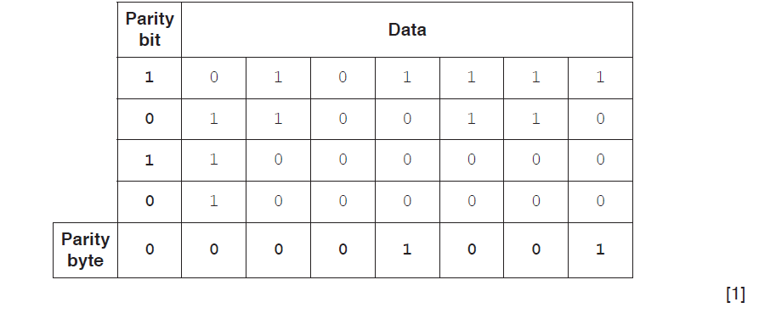

**(c)** The following table shows five error detection measures.

Put **one** tick (√) in each row to indicate whether the measure is validation or verification.

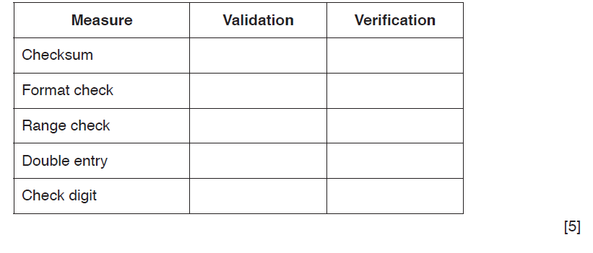

5.

Parity bits can be used to verify data.

**(a)** The following binary number is transmitted using **odd** parity.

Add the missing parity bit.

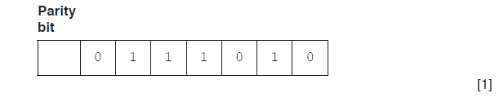

**(b)** In the following parity block, the first column contains the parity bits, and the last row contains the parity byte. A device transmits the data using **even** parity.

**Circle** the error in the data being transmitted.

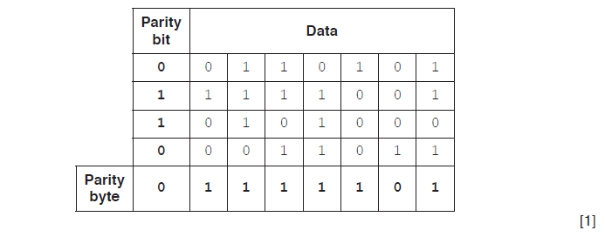

**(c)** Four error detection measures are shown.

Draw **one** line from each error detection measure to indicate whether it is verification or validation.

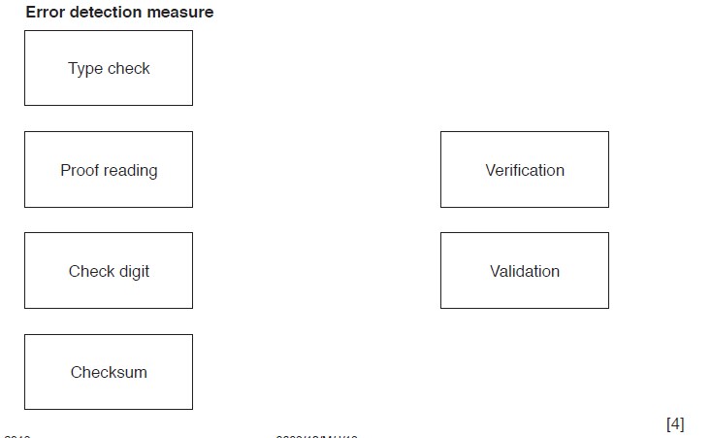

6.

Describe **one** way of ensuring that the integrity of the data is retained during the transmission stage.

.......................................................................................................................................

.......................................................................................................................................

.......................................................................................................................................

.......................................................................................................................................

....................................................................................................................................

...................................................................................................................................[4]

7.

Parity bits can be used to verify data.

**(a)** The following binary number is transmitted using **even** parity.

Add the missing parity bit.



**(b)** In the following parity block, the first column contains the parity bits, and the last row contains the parity byte. A device transmits the data using **even** parity.

**(i)** Circle the error in the data transmitted.

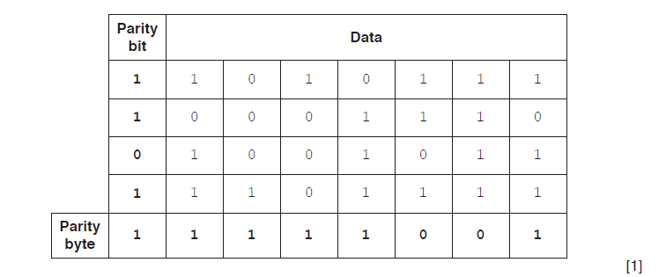

**(ii)** Explain how you identified the error.

.......................................................................................................................................

.......................................................................................................................................

.......................................................................................................................................

...................................................................................................................................[2]

**(c)** The data received can contain errors that are not detected using parity bits.

Explain how this can happen.

.......................................................................................................................................

.......................................................................................................................................

...................................................................................................................................[2]

**(d)** Parity is not the only method to verify the data has been sent correctly.

Name **and** describe **one** other method of data verification during data transfer.

Name .............................................................................................................................

Description ....................................................................................................................

.......................................................................................................................................

..................................................................................................................................

.................................................................................................................................[3]

8.

A computer receives data from a remote data logger. Each data block is a group of 8 bytes.

A block is made up of seven data bytes and a parity byte.

Each data byte has a parity bit using odd parity. The parity byte also uses odd parity.

The following table shows a data block before transmission. Bit position 0 is the parity bit.

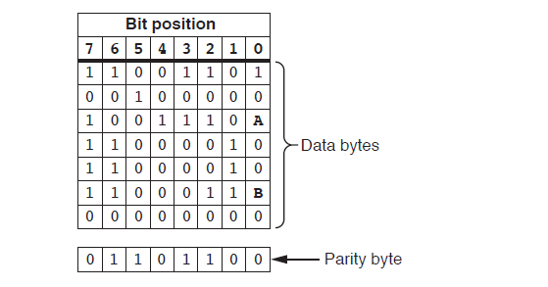

**(a) (i)** Describe how the data logger calculates the parity bit for each of the bytes in the data

block.

.......................................................................................................................................

.......................................................................................................................................

...................................................................................................................................[2]

**(ii)** State the two missing parity bits labelled **A** and **B**.

**A** = ..............................

**B** = .............................. [1]

**(iii)** Describe how the computer uses the parity byte to perform a further check on the

received data bytes.

.......................................................................................................................................

.......................................................................................................................................

...................................................................................................................................[2]

**(b) (i)** A second data block is received as shown in the following table. There are errors in this data block.

Identify and then circle **two** bits in the table which must be changed to remove the errors.

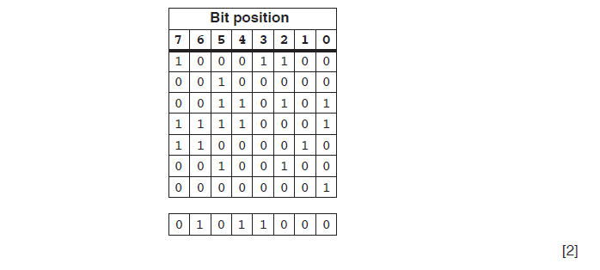

**(ii)** Explain how you arrived at your answers for **part (b)(i)**.

.......................................................................................................................................

…………........................................................................................................................

..................................................................................................................................[3]